Comparison of both models
What We Looked At | Linear Regression (The Straight Line) | Random Forest (The Decision Trees) | Who Won?
Accuracy Grade (R² Score) | 48.4% | 96.8% | Random Forest (By a landslide!)
Average Miss (MAE Error) | Missed by 1.78 Million Tons | Missed by only 78,020 Tons | Random Forest (95% more accurate!)
Realistic Guesses? | No. Sometimes guessed impossible negative numbers. | Yes. Kept all guesses realistic and physically possible. | Random Forest

Visualizing the Showdown
When we looked at the final graphs of how the models performed, the difference was clear:
- The Random Forest Graph: The data points formed a beautiful, tight, straight line. When actual production went up, the model's guesses went up right along with it. It handled tiny harvests and massive harvests with the same high level of precision.
- The Linear Regression Graph: The points flew completely wild. As soon as harvests got large, the model started guessing way too low. Even worse, it guessed that some regions would produce less than zero tons of food, which is impossible.
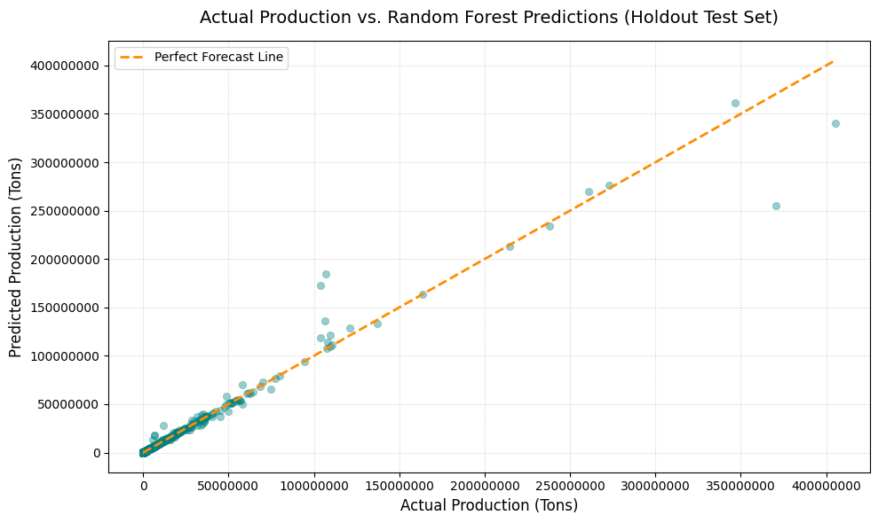

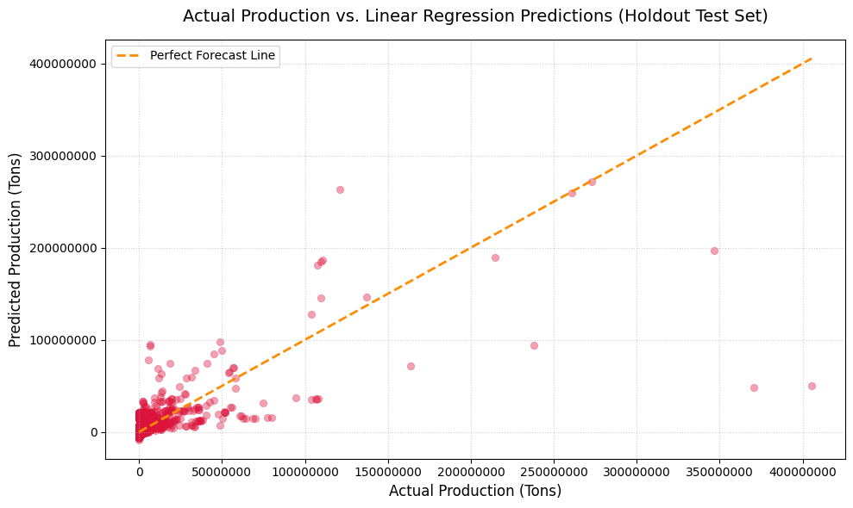

What This Means for the Business
Because the Random Forest model scored a 96.8% on its final exam, companies can confidently use it to make real-world decisions:
- Smart Shipping & Storage: Companies can predict exactly how much crop volume will come out of a region months before it is actually harvested. This allows them to book shipping containers and warehouse space early, saving massive amounts of money.
- Spotting Problems Early: If a region reports a harvest that is drastically lower than what our model predicted, the system can instantly trigger an alert. This helps agricultural teams quickly find localized droughts, crop diseases, or human reporting errors.
- Safe Sourcing: If a specific country is running low on a crop, companies can use the model to simulate alternative regions and crops to see where they can pivot their supply chain safely without losing volume.
Final Verdict: The Random Forest model is completely approved, highly stable, and ready to go to work!

